Create a node Project

1. Create a new Folder under your favourite drive
2. Open the command prompt and move that folder example: **MynodeProject**
3. Open Visual Studio and select your project folder **MynodeProject**
4. Create a file app.js (to enter entry point while create project)
5. Go to view🡪 Terminal or command prompt move to the folder
6. Create a package.json file to create project using **npm init**

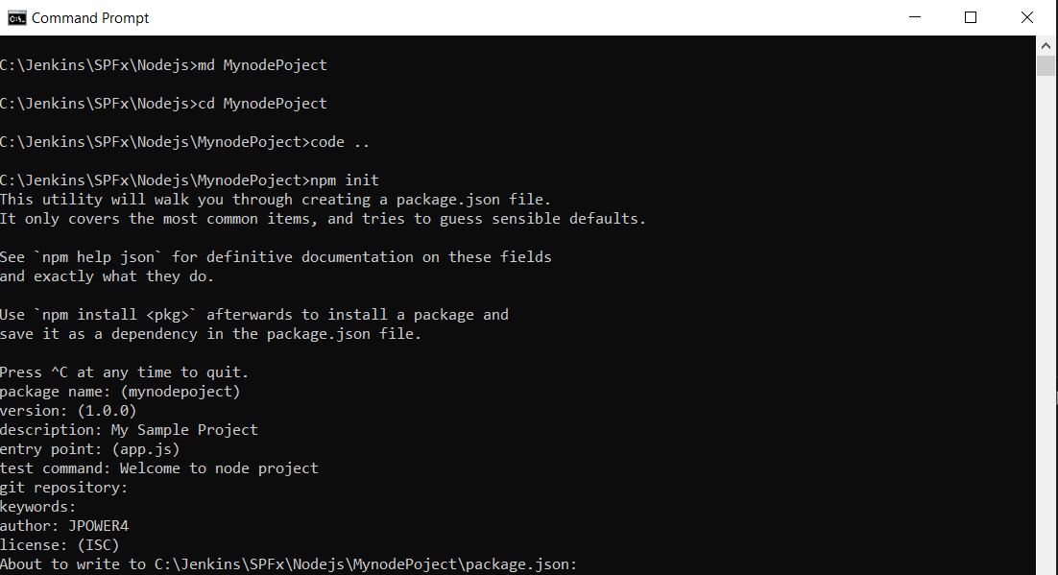

1. Fill all required information’s
   1. PakageName
   2. Version
   3. Description
   4. Entry point
   5. Test command
   6. Git repository if required
   7. Author
   8. License
2. Create a folder called “Modules” or any name
3. Create a file under Modules 🡪 firstmodule.js and paste below code

*exports.myDateTime  =   function ()  {*

*return  Date();*

*};*

1. Call the single method module
2. Move to app.js file
   1. var dt = require("./Modules/firstmodule");
   2. console.log(dt.myDateTime());
3. to execute go to terminal or command prompt
   1. node app.js

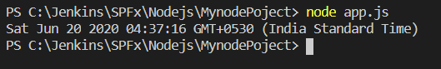

1. How to export multiple methods
2. Create new file “secondmodule” under modules folder ie. **Secondmodule.js**
3. Add below code

*var  myfunctions  =   {*

*getDate:   function()  {*

*console.log(Date());*

*return  "Current Date and time printed";*

*},*

*addval:   function(val1, val2)  {*

*console.log(val1 + val2);*

*return "valueadded";*

*}*

*}*

*module.exports  = myfunctions;*

1. Export multiple functions
2. Accessing the functions
3. Add below code in app.js file

*var dt2 = require("./Modules/secondmodule");*

*console.log(dt2.getDate())*

*console.log(dt2.addval(10, 101));*

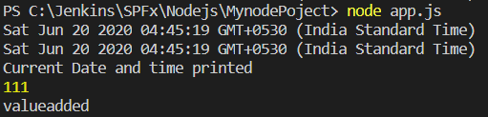

1. Start the project using npm start
2. Open package.json file
3. Add start parameter with node app.js
   1. "start": "node app.js"
   2. Don’t forget the comma

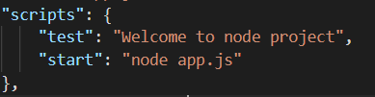

1. Run the project now using **npm start** command
2. Output

